**PROJECT REPORT**

1. Title of the project **: Student Report Card**
2. Object of project : The program will ask for the student name , roll, and marks.

**Group members:**

Name: Md. Marzukul Islam

ID: CSE 063 07497

**INTRODUCTION**

Project work for University has been made in “C++” Language. Project work consist of a program for Student report card.

Our program consists of file on compiling the program, it asks for various choices from different options.

1.CREATE STUDENT RECORD

2.DISPLAY ALL STUDENTS RECORDS

3.SEARCH STUDENT RECORD

4.MODIFY STUDENT RECORD

5.DELETE STUDENT RECORD

6. DISPLAY CLASS RESULT

7. EXIT

On entering the choice no., it will reform the different functions.

**Step 1:-**

This step contains the file that is used in the whole program. In this step there is use of the header files which are as follows:-

1. **Iostream :** This stand for standardinput output.

**It includes:**-

1. Cin>> : Input from users.
2. Cout<< : Writes formatted output in screen.
3. Rename () : Rename the file.
4. Remove() : Remove the file.
5. **Fstream :** This stand for file read and write.
6. **Iomanip :** This stand for input output manipulation.
7. **Cstring :** It shows different types of string manipulation and memory manipulation path.

**Step 2:-**

From here the actual program starts first of all we find void main () function which starts the program then there is a opening brace. In it different type of variables and data types are defined.

Ans and choice variables are define as character data type.

In class , class is being declared in which different types of variable and functions.

The file name is in mark .dat and mode is in read and write mode.

**Step 3:-**

Here main menu is displayed on the screen . here size of operator is used which is linked with class. In this step there are seven menus and as follows.

1. CREATE STUDENT RECORD

2. DISPLAY ALL STUDENTS RECORDS

3. SEARCH STUDENT RECORD

4 .MODIFY STUDENT RECORD

5. DELETE STUDENT RECORD

6. DISPLAY CLASS RESULT

7. EXIT

In this step , switch – case statement are used.There is one message is printed “Enter your choice”. After selecting a particular case program enter the particular case.

**Step 4:-**

**On selecting case 1,** it will ask to enter Students information including roll no., name, marks obtained in different subjects.

Here, integer,character type data are entered.

**Different types of data are as follows:-**

1. **Character data type:** Student name.
2. **Integer data type:** roll no., marks obtained in different subject.
3. **Float data type:** percentage.

**Flow chart**

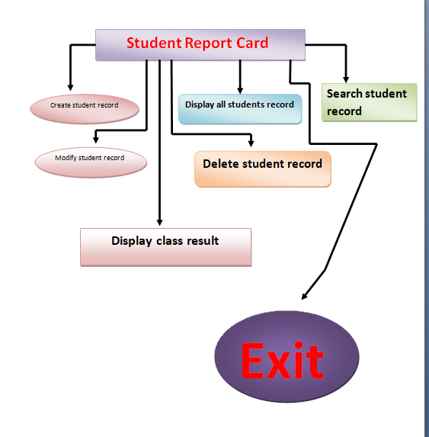

**Output**

